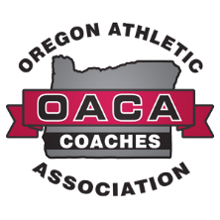

OACA DIRECTORS AND PRESIDENTS SCHOLARSHIP APPLICATION

The OACA, along with support from Jennifer and Jarod Teeter, has created a scholarship for coaches to recognize and nominate a deserving senior student-athlete. This scholarship is sponsored by former OACA directors and presidents who desire to “give back” in appreciation of the OACA.
Criteria:
- Outstanding character, sportsmanship and leadership – a student-athlete who truly stands out among his or her peers.
- Emphasis placed on student pursuing a career in education.
- Emphasis given to multi-sport athletes.

If you have a student-athlete who meets the above criteria, please provide information below and submit a Nomination Rationale detailing why you are nominating the student-athlete.

Requirements:
- Completed Application Form (only typed applications will be considered)
- All emailed documents submitted as one PDF file
Application Deadline: March 15, 2025
You may submit this application via email or mail.
Submit by email to: melissa@oregoncoach.org
Submit by mail to: OACA
222 First Ave. W
Suite 220
Albany, OR 97321

Questions? Please contact Melissa at melissa@oregoncoach.org or call our office at
541-928-2700.

Thank you for your nomination

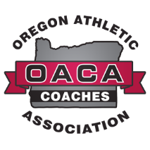

OACA DIRECTORS AND PRESIDENTS SCHOLARSHIP APPLICATION

1) Student-Athlete Contact Information
Name:
School:
School Classification: 1A 2A 3A 4A 5A 6A
Home Address:
City:
State:
Zip Code:
Phone:
Email:
Nominator’s Name & Email (required):
School Counselor Name & Email:

Nomination Rationale:

